EXPT NO: 9 | Implementation of a Markov Decision Process (MDP) for Decision-Making in a Dynamic Environment.
DATE: 21.10.2025

PRE-LAB QUESTIONS
- What is a Markov Decision Process (MDP)?
ANS:
A Markov Decision Process (MDP) is a mathematical framework used to model decision-making situations where outcomes are partly random and partly under the control of an agent. It provides a way to determine optimal policies that maximize cumulative rewards over time.

- What are the main components of an MDP (states, actions, transition probabilities, rewards, discount factor)?
ANS:
The main components of an MDP are states (S) representing situations, actions (A) representing possible decisions, transition probabilities (P) defining the likelihood of moving between states, rewards (R) giving feedback for actions, and a discount factor (γ) that values future rewards less than immediate ones. Together, these elements define how an agent interacts with its environment.

- How does an MDP differ from a regular Markov Model?
ANS:
A regular Markov Model deals only with state transitions based on probabilities, without involving any decision-making. In contrast, an MDP includes actions and rewards, allowing an agent to make optimal choices to maximize expected returns.

- Why are MDPs useful for AI-based decision-making in dynamic environments?
ANS:
MDPs help AI systems plan optimal actions under uncertainty by balancing exploration and exploitation. They provide a structured approach to long-term decision-making, making them ideal for adaptive and goal-oriented behaviour.
- Give two real-world applications of MDPs in Artificial Intelligence.
ANS:
MDPs are used in robot navigation, where robots plan paths with uncertain movement outcomes, and in reinforcement learning, where agents learn optimal strategies in games or autonomous control systems. They are also widely applied in finance, healthcare, and resource management.

IN-LAB EXERCISE
OBJECTIVE:
To implement a simple Markov Decision Process (MDP) in Python for modeling and solving a sequential decision-making problem using the Value Iteration algorithm.

PROCEDURE:
Problem Scenario
- Problem Type: Sequential Decision-Making under Uncertainty
- Model: Markov Decision Process (MDP)
- Goal: To compute the optimal policy for an AI agent navigating a grid environment with rewards and penalties.

Implementation Steps:

Part A – Model Initialization
- Import the required libraries: numpy and matplotlib.
- Define:
- A set of states (e.g., positions in a grid: S1, S2, S3, S4).
- A set of actions (e.g., ['Left', 'Right']).
- Transition probabilities for moving between states.
- Reward values for each state or action.
- A discount factor (γ) for future rewards.

Part B – Implement Value Iteration
- Initialize the value function for all states to zero.
- For each state:
- Compute the expected value of each possible action.
- Update the state’s value using the Bellman optimality equation:
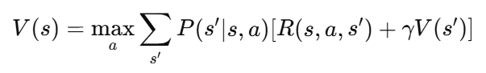
- Repeat until values converge.
- Extract the optimal policy by choosing the action with the highest value for each state.

Part C – Simple Scenario Example
Let’s consider a 3-state environment:
  - S1 (Start)
  - S2 (Intermediate)
  - S3 (Goal): [0, 1, 1, 1, 0, 0, 1, 1, 0, 1]
  - Discount factor γ = 0.9
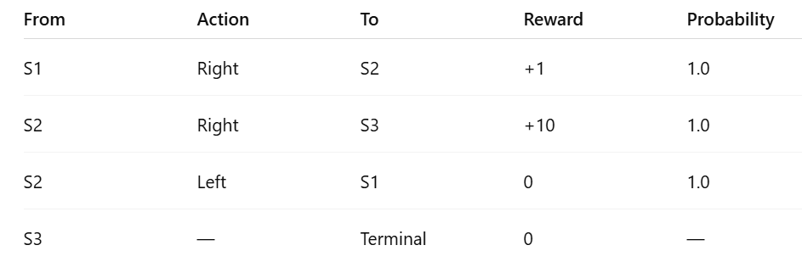
Part D – Visualization
- Display state values as a bar chart.
- Annotate each state with its optimal action.

SCREENSHOT OF CODE
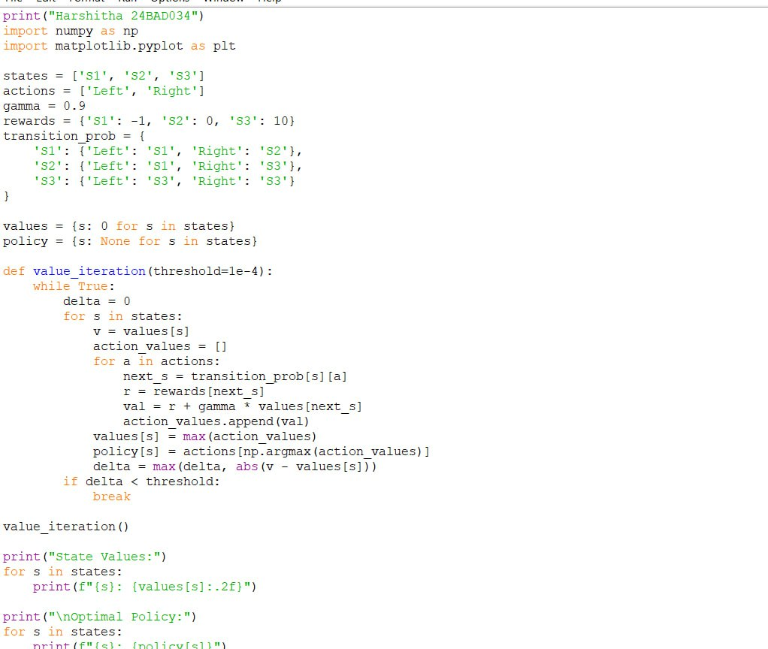
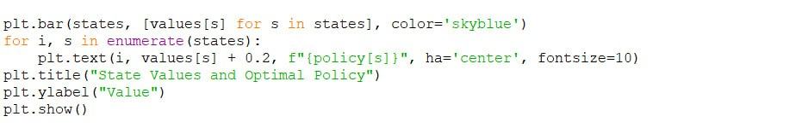

SCREENSHOT OF OUTPUT
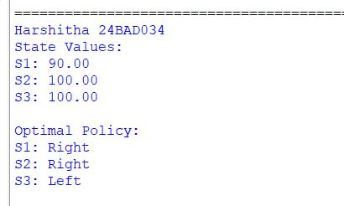

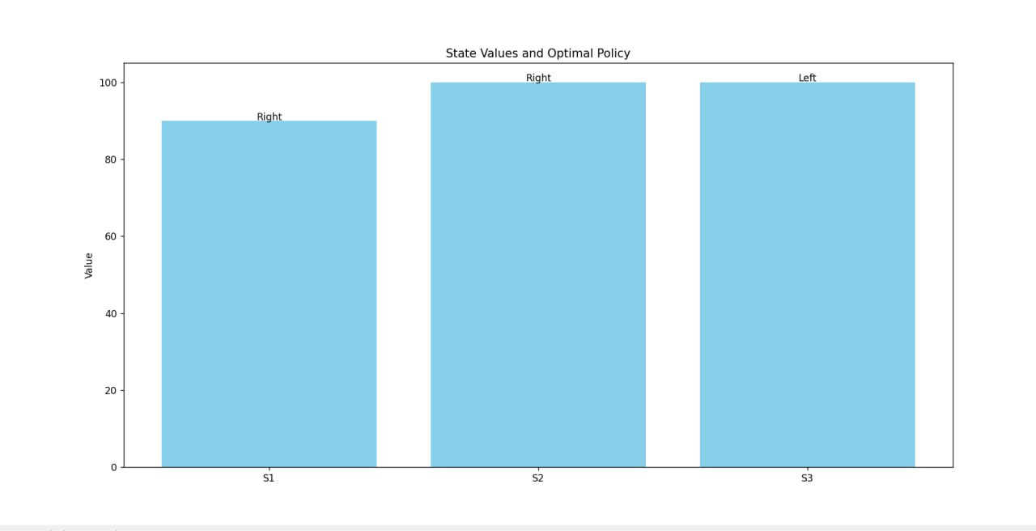

POST-LAB QUESTIONS (Write the answers in your AI and Automation Notebook)
- What is the role of the discount factor (γ) in MDPs?
ANS:
The discount factor (γ) determines how much future rewards are valued compared to immediate rewards. A smaller γ makes the agent focus on short-term gains, while a larger γ encourages long-term planning and delayed rewards.

- How does Value Iteration differ from Policy Iteration?
ANS:
Value Iteration repeatedly updates state values using the Bellman equation until convergence, then extracts the optimal policy. Policy Iteration, on the other hand, alternates between policy evaluation and policy improvement steps, refining the policy directly instead of focusing solely on value updates.

- If you increase γ from 0.9 to 0.99, what happens to the optimal policy?
ANS:
When γ increases, the agent places more importance on future rewards and becomes more farsighted. As a result, the optimal policy may shift toward actions that yield higher long-term benefits rather than immediate rewards.

- Explain why MDPs are useful for AI-based decision-making in uncertain environments.
ANS:
MDPs allow AI systems to make rational decisions when outcomes are uncertain by modelling both probabilities and rewards. They provide a structured way to choose actions that maximize expected utility over time, even when transitions are not fully predictable.

- Suggest a real-world example of using MDPs for energy-efficient AI systems.
ANS:
MDPs can be applied in smart grid energy management, where the system decides when to store, use, or sell electricity to minimize cost and maximize efficiency. They’re also used in data centre cooling optimization, helping AI balance performance with reduced energy consumption.

RESULT:
The Markov Decision Process (MDP) was successfully implemented in Python. The Value Iteration algorithm computed optimal state values and derived the best policy for each state. The model demonstrated how AI agents can make optimal decisions in dynamic environments.

ASSESSMENT (Write in your lab notebook)
Description | Max Marks | Marks Awarded
Pre Lab Exercise | 5
In Lab Exercise | 10
Post Lab Exercise | 5
Viva | 10
Total | 30
Faculty Signature

